
Name – Mansi Sharma
PRN- 1032233789
Roll No- 16
Batch - F1
FSD Laboratory 07
Aim: Develop a full stack web application using MERN stack to perform CRUD operations.
Objectives:
1. To develop full-stack web projects using the MERN stack.
2. To learn database connectivity using fetch api.
3. To perform insert, update, delete and search operations on database.
Problem Statements:
CRUD Operations using MERN stack:
1.Student can create a React form or use existing/ implemented HTML form for Student’sRegistration System with the fields mentioned: First name, Last name, Roll No/ID, Password,Confirm Password,Contact number and perform following operations
1.Insert student details -First name,Last name, Roll No/ID, Password, Confirm Password,Contact
number
2.Delete the Student records based on Roll no/ID
3.Update the Student details based on Roll no/ID- Example students can update their contact
details based on searching the record with Roll no.
4.Display the Updated student details or View the Students record in tabular format.
Theory:
1. What is MERN stack?
MERN is a full-stack JavaScript technology stack used to build modern web applications.
It consists of:
- MongoDB – Database (NoSQL)
- Express.js – Backend framework (Node.js)
- React – Frontend library
- Node.js – Runtime environment

How it works together:
- React → handles UI (what users see)
- Node.js + Express → handles server logic (APIs)
- MongoDB → stores data (like users, posts, etc.)
Simple flow:
User → React UI → API call → Express/Node → MongoDB → Response → UI update
2. Use of Fetch api.
The Fetch API is used in JavaScript to make HTTP requests (like GET, POST) to servers.

Why it’s used:
- To get data from backend APIs
- To send data (forms, login info, etc.)
- Works with Promises (modern async handling)

Common Uses:
- Fetching user data
- Submitting forms
- Calling REST APIs
- Updating UI dynamically
FAQ:
1. What makes MERN stack the fastest growing tech stack?

1. Single Language (JavaScript Everywhere)
- Frontend + Backend both use JavaScript
- Easier to learn and faster to develop

2. High Performance
- Node.js is non-blocking (handles multiple requests efficiently)
- Great for real-time apps (chat apps, streaming)

3. Component-Based UI (React)
- Reusable components
- Faster UI development
- Strong ecosystem

4. Flexible Database (MongoDB)
- No fixed schema (easy to scale)
- Works well with JSON-like data

5. Huge Community & Demand
- Backed by companies like Meta (React)
- Tons of libraries, tools, and jobs available

6. Full Stack Development Made Easy: One developer can handle:
  - Frontend
  - Backend
  - Database
Output: Screenshots of the output to be attached.
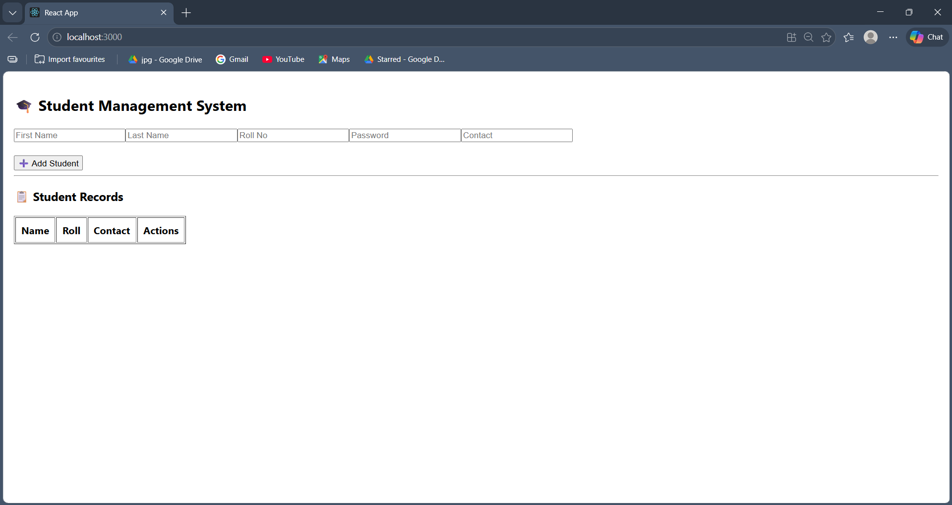
ADD
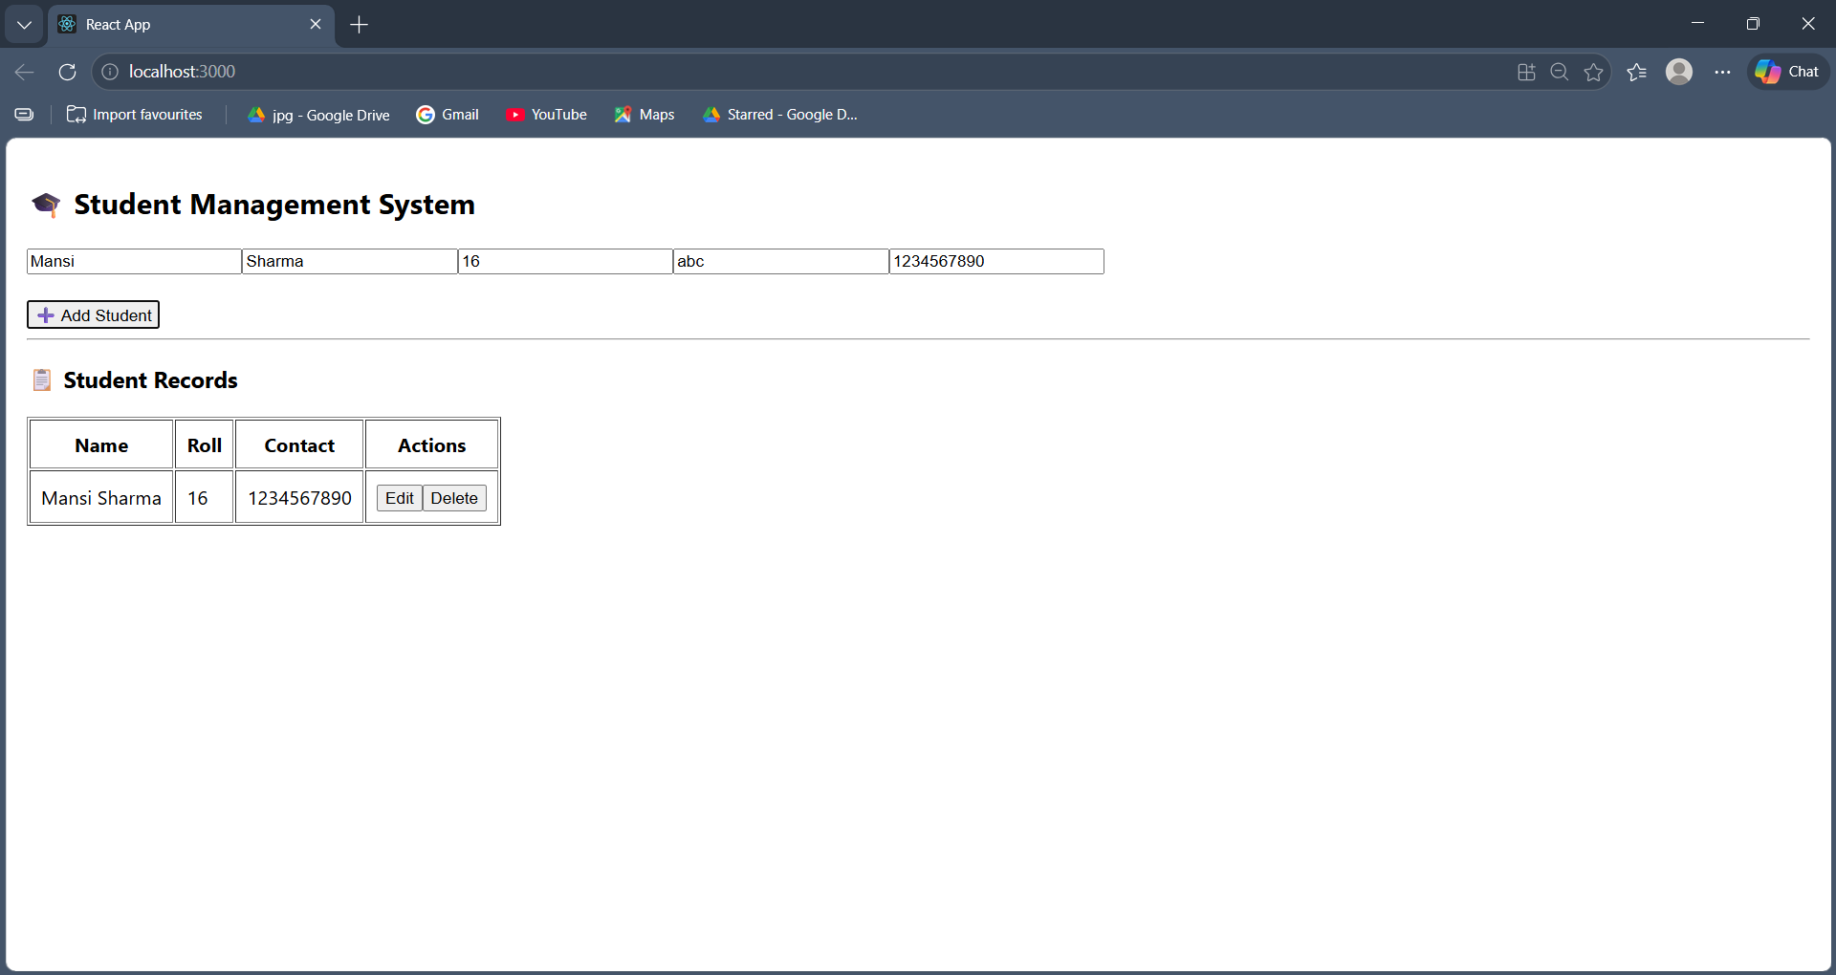
UPDATE
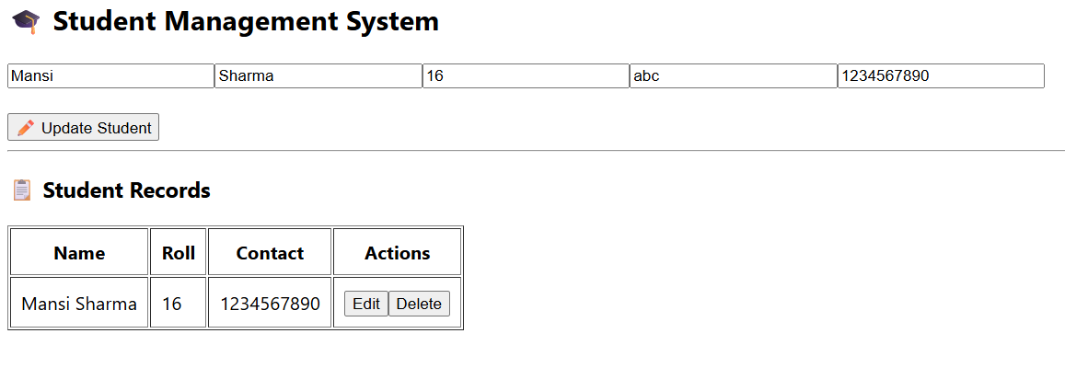
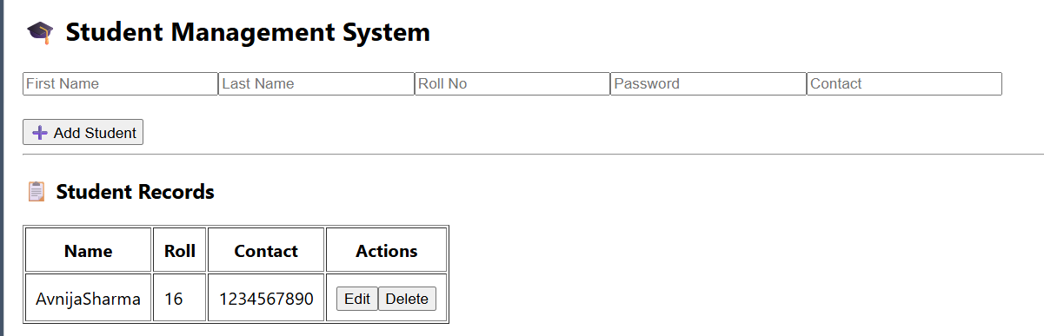
Delete
